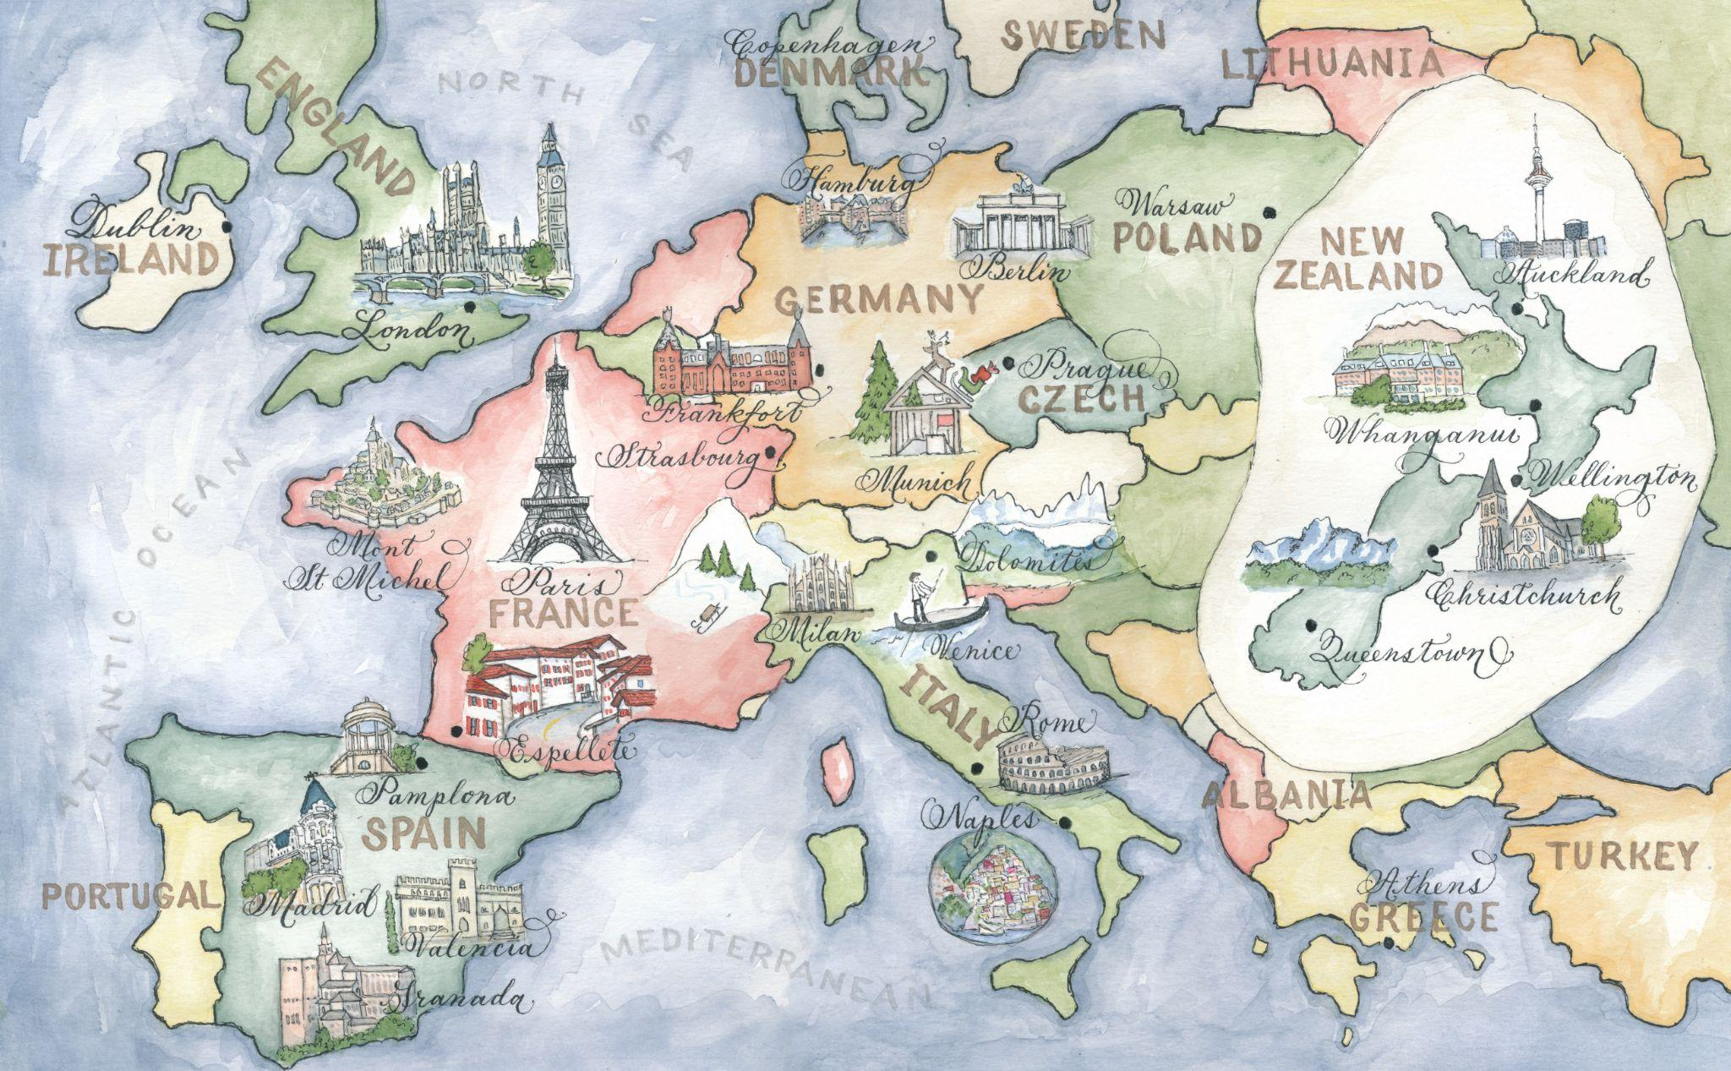

MAPS ONLY
Calligraphy Client Questionnaire

 | Client Name | Enter information
 | Bride/Groom, etc | Enter information
 | Client Phone | Enter information
 | Contact Email | Enter information
 | Mailing Address | Enter information
 | Event Date | Enter information
GENERAL DESIGN INFORMATION

WHERE DO YOU FIND DESIGNS BY ROBYN LOVE?

Completion Deadlines
 | PROJECT/COMPONENT |  | DEADLINE
 | Map
 | Save the Dates
 | Invitations
 | Day of Event Collateral
 | Other: list

Calligraphy Font Choice: ________________________
Pick a font from this page on my website. There are many fonts I use.
But I also specialize in designing a custom font for your needs.

All SHIPPING is paid for by the customer in the final bill. Please select your desired shipping method:

_____ OVERNIGHT UPS
_____ 2 DAY UPS
_____ GROUND UPS
_____ PRIORITY MAIL USPS
_____ FIRST CLASS USPS

Event Style. Describe the style of your Event. What do you want your guests to think about this event? How is the final design going to be a part of that picture?

EVENT COLORS
Enter Information

Desired Completion Date: _________________________

Style: Describe the style of your wedding, what you want the guests to think about this special day and how your calligraphy will be a part of that picture:

What are your wedding colors?

Do you want a custom font?

ADDITIONAL QUESTIONS AND DIRECTIONS FOR MAPS

I love designing maps! So let’s get started!!

I need you to fill out in as much detail as possible everything that you want on your map below. I will design your map in fitting with what is stated below. So tell me everything you can as if I have never been there and you are trying to give me a feel for the local scene, how the city is different from others, what you like most about it, what needs to be there for people to know what city it is, etc. If I finish and the style isn’t what you had in mind, but you didn’t say anything on this questionnaire to tell me what you wanted it to be like, there will be additional fees to make the changes. At any time, if you change something for the map, you are required to alter this questionnaire and email the new copy to me. Info sent over email is too hard to keep track of and I would like it in print in your folder! Thanks!!!

Please read: Any additions wanted to the map after I have finished it, that were not on this original questionnaire, will result in additional fees. (ie. Adding another building after it is finished) your initials below show that you have read this and agree to pay any applicable fees Please initial here ( )

Area for the map (i.e. New York City, LA, etc):
Final print dimensions (i.e. 5x7):
Do you want me to print the maps for you?
If yes, how many?___

Coloring:
_____ Black and white (lines and background can then be digitally changed to any color)
______ colors when in digital format
_____ Watercolor
**** Please state any colors you don’t want on the map…like pink (giggle)!

What are you using your map for:
____ Save the Date
___ Postcard ___ Double sided ____ Magnet ___ Single sided
____ Invitation
___ As an enclosure ___ As invitation ___
____ In welcome boxes
Other______________

Please give me a detailed description of how you would like the map to “feel”: (ie not girly, vintage, fun, silly, outdoorsy, frilly, etc)

Please list any special wording that you want on the map and where you would like it placed: (here is where you tell me what you would like on your plaque)

What streets or specific area do you want the map to stop at:
North:
South:
East:
West:

What angle do you want the map’s perspective to come from (ie above, from the south, northeast, etc):

Is there anything that you don’t want on the map? (i.e. freeways, side streets, street names, flowers, cars )

Please list all locations for the map below, including addresses if necessary to distinguish PLUS add a photo if you want it illustrated OR tell me what symbol you would like to represent the location: please insert images right here of each building you would like me to paint. I need them here not as separate files. Label each.

Do you want any cute illustrations on the map that aren’t actually locations, like a tandem bike, riverboat, carriage, old car, fish, picnic blanket at park, birds, mammals, humans, etc)? Please list and give location on map is known.

How I make your map just right:
- NOW, you will need to get online to google maps (maps.google.com)
- On the left you will see “my maps”. Click!
- Then click the box “get started”.
- Make a title for the map and click the “save” box.
- You are ready to add locations!
  - To add actual addresses, type them in the “find” box at the top of the page. Once google locates the address a balloon will appear on the map and a dialog balloon above that. In the dialog balloon click “save to…”, then choose the title of your map!
  - Continue adding all your locations
  - If there is a location that doesn’t have an address, you can add it by going to your map and using the blue balloon box in the top left corner of the map. Place the balloon anywhere you want and name it!
- Remember to save your map by clicking “edit” and “save”.
- Above the map on the right side click “link”. Copy the link they provide and paste it into an email for me to access the map! Make sure you share it with this email: hello@designsbyrobynlove.com

INFORMATION FOR PRINTS BACKSIDE

Font: _________________________

Design
Enter Information

What type of Printing do you want: : ____Flat _____Raised _____Letterpress

Final Wording: (replace wording in the boxes below with yours

Wording
Save the Date

Michelle and Todd

04.07.33
New York, New York

Invitation to follow

Return Address
Michelle and Todd
355 Ninth Avenue
New York, New York
1 0 0 1 1

