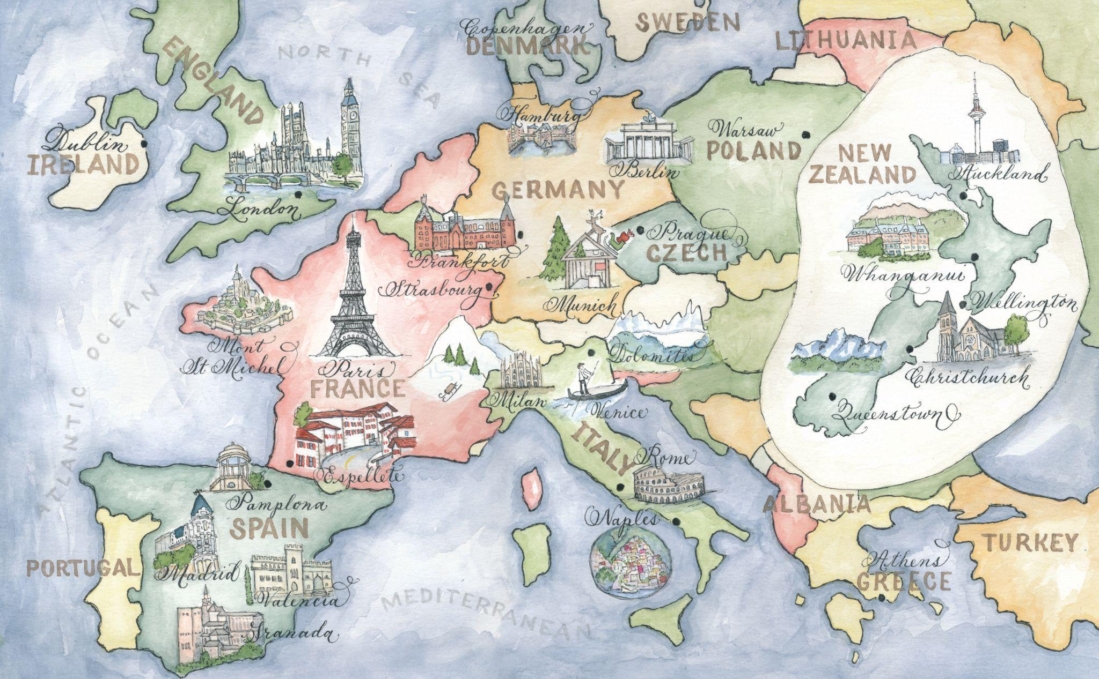

CORPORATE MAPS
Client Questionnaire

 | Client Name
 | Company Name | Enter information
 | Client Phone
 | Contact Email
 | Mailing Address
 | Due Date
GENERAL DESIGN INFORMATION

WHERE DO YOU FIND DESIGNS BY ROBYN LOVE?

Completion Deadlines
 | PROJECT/COMPONENT |  | DEADLINE
 | Map
 | Prints
 | Other: list

Calligraphy Font Choice: ________________________
Pick a font from this page on my website. There are many fonts I use.
But I also specialize in designing a custom font for your needs.

All SHIPPING is paid for by the customer in the final bill. Please select your desired shipping method:
_____ OVERNIGHT UPS
_____ 2 DAY UPS
_____ GROUND UPS
_____ PRIORITY MAIL USPS
_____ FIRST CLASS USPS

IMPORTANT: Any additions or major changes to the map after the painting is finished, that were not on the original questionnaire or stated in the layout process, will result in additional fees. Your initials here show that you have read this and agree to pay any applicable fees. Please initial here ( )

I need you to fill out in as much detail as possible everything that you want on your map below. I will design your map in fitting with what is stated below. So tell me everything you can as if I have never been to the location and you are trying to give me a feel for the local scene, how the city is different from others, what you like most about it, what needs to be there for people to know what city it is, etc. If I finish and the style isn’t what you had in mind, but you didn’t say anything on this questionnaire to tell me what you wanted it to be like, there will be additional fees to make the changes. At any time, if you change something for the map, you are required to alter this questionnaire and email the new copy to me. Info sent over email is too hard to keep track of! Thanks!!!

Map Style. Below describe the style of your business and what style you would like the map to have. Please include color boards and imagery to give me a clear picture. Please include here any of my map styles that you would like me to reference. You can find an extensive gallery of my maps at https://www.designsbyrobynlove.com/calligraphy-map-gallery

Location for the map: ________________________

WHAT ARE YOU USING THE MAP FOR?
Prints. Are you interested in printing? Please describe what you are looking for.

Final Dimensions in inches or pixels

Coloring
Black and White
Black and White with digital coloring
Partial Watercolor
Full Watercolor

List any special wording for your map. If you want a plaque please put the wording here and below insert an image of what plaque style you would like me to use.
Enter Information

Borders. What streets or specific areas do you want the map to stop at?
North:
South:
East:
West:

ANYTHING THAT YOU DONT WANT ON THE MAP

LOCATIONS

Please list all locations for the map below, including addresses if necessary to distinguish where they belong on the map PLUS add a photo if you want it illustrated OR tell me what symbol you would like to represent the location: please insert images right here of each buildings you would like me to paint. I need them here not as separate files. Label each exactly as you would like it labeled on the map. An example is below.

- “Prendie” 401 N. Lansdowne Ave Drexel Hill, PA 19026 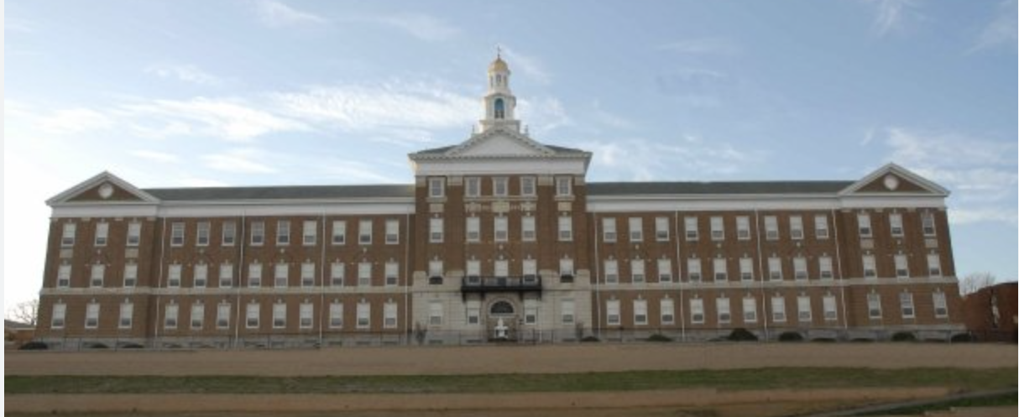

ICONS

Icons. Anything that you would like on the map that isn’t a location should be listed below. For example, if you wanted a picnic blanket with a basket, list it here and let me know where on the map you prefer for it to go. Photos of what you want are helpful.

GOOGLE MAP

How I make your map just right:
- NOW, you will need to get online to google maps (maps.google.com)
- On the left you will see “my maps”. Click!
- Then click the box “get started”.
- Make a title for the map and click the “save” box.
- You are ready to add locations!
  - To add actual addresses, type them in the “find” box at the top of the page. Once google locates the address a balloon will appear on the map and a dialog balloon above that. In the dialog balloon click “save to…”, then choose the title of your map!
  - Continue adding all your locations
  - If there is a location that doesn’t have an address, you can add it by going to your map and using the blue balloon box in the top left corner of the map. Place the balloon anywhere you want and name it!
- Remember to save your map by clicking “edit” and “save”.
- Above the map on the right side click “link”. Copy the link they provide and paste it into an email for me to access the map! Make sure you share it with this email: hello@designsbyrobynlove.com

PRINTS

INFORMATION FOR PRINTS

Font: _________________________

Layout of Print with Sizes
Enter Information

PRINTING What type of printing do you want for the
_____ FLAT
_____ RAISED
_____ LETTERPRESS

Wording. replace wording in boxes below with yours if needed. Duplicate box if needed

___inside a folded card ____backside of card folded card ____backside of flat card
Join us at our new location

Your Store Name
6754 Fifth Avenue
New York, New York

Grand Opening 4/4/44

Return Address for envelopes
Your Store Name
6754 Fifth Avenue
New York, New York
1 0 0 1 1

