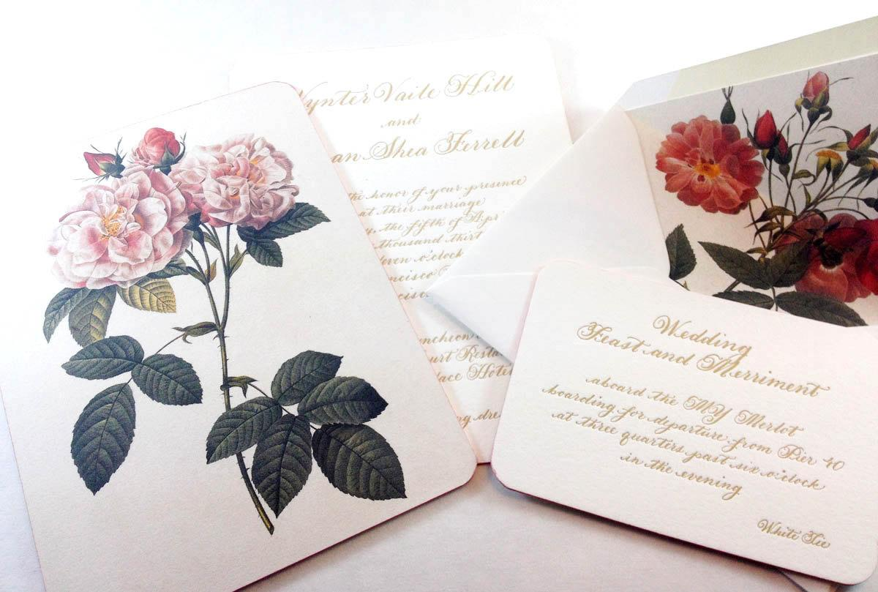

INVITATIONs

 | Client Name | Enter information
 | Bride/Groom, etc | Enter information
 | Client Phone | Enter information
 | Contact Email | Enter information
 | Mailing Address | Enter information
 | Event Date | Enter information

GENERAL DESIGN INFORMATION

WHERE DO YOU FIND DESIGNS BY ROBYN LOVE?

Completion Deadlines
 | PROJECT/COMPONENT |  | DEADLINE
 | Save the Dates
 | Invitations
 | Day of Event Collateral

Calligraphy Font Choice: ________________________
Pick a font from this page on my website. There are many fonts I use.
But I also specialize in designing a custom font for your needs.

All SHIPPING is paid for by the customer in the final bill. Please select your desired shipping method:

_____ OVERNIGHT UPS
_____ 2 DAY UPS
_____ GROUND UPS
_____ PRIORITY MAIL USPS
_____ FIRST CLASS USPS

Event Style. Describe the style of your Event. What do you want your guests to think about this event? How is the final design going to be a part of that picture?

EVENT COLORS
Enter Information

INVITATION SUITE INFORMATION

WORDING
Please replace wording in these boxes with your own
Delete any boxes below that are not needed, copy and paste a box to add more

MAIN INVITATION WORDING
Mr. and Mrs. Jeffrey Feste
request the honor of your presence
at the wedding mass of their daughter
Sydney Marie
to
Mr. James Mark McCostlin
son of Mr. and Mrs. Mark McCostlin
Saturday, the twenty-third of October
two thousand thirty
at half after one o’clock in the afternoon
Saint Alphonsus Catholic Church
8896 West Wellington Avenue
Chicago

RSVP WORDING
The honour of your reply is requested by
August 14, 2030

M_______________________________

____Accepts with joy
____Declines with regret

Number attending ____

RETURN ADDRESS
Sydney and James
123 Twentieth Avenue
New York, New York
1 0 0 1 1

RECEPTION ENCLOSURE
Dinner & Dancing
at six o’clock in the evening
Murphy Auditorium
50 East Erie Street
Chicago

Visit www.jamesandsydney.net for accommodations
and information about our wedding weekend

ADDITIONAL ENCLOSURE WORDING
Enter Information

*******Delete any boxes above that are not needed, copy and paste a box to add more******

DETAILS

PRINTING CHOICE
Mark all that apply

___ Flat printing ___Raised Thermography printing

___Letterpress ___Foil Printing

Invitation Layout
You may also include the name of a particular invitation layout in the shop!

Pieces Desired
Flat Invitation
Backer Cardstock
Pocketfold
Gatefold
Folded Invitation Card
Standard RSVP with Envelope
Postcard RSVP
Folded RSVP
Outer Envelope
Inner Envelope
Custom Envelope
Reception Card
Accommodations Card
Map
Additional Enclosure:
Ribbon
Lace
Belly Band
Other:

Custom Artwork: __________________________________
Describe any custom artwork you would like included.
You may also just refer to a particular invitation in the shop!
Or insert a sketch or inspiration picture.

PAPER CHOICE
Mark all that apply

Off White Cotton Paper:
____Standard 118lb ____2ply 220lb ____4ply

Black Paper:
____Standard 110lb ____2ply ____4ply

Other Paper: Please list color
____Bright White Cotton ____Cotton Colored ____Matte Other Colored ____Metallic Colored

INK COLORS
Enter Information

MAIN INVITATION SIZES | ___5x7  ___5.25x7.25  ___4x6  ___5.5x8.5  ___6.5x6.5  ___6x9  ___4x9  ____Other:

